Kenya Fact File

Where is Kenya?

Colour in Kenya
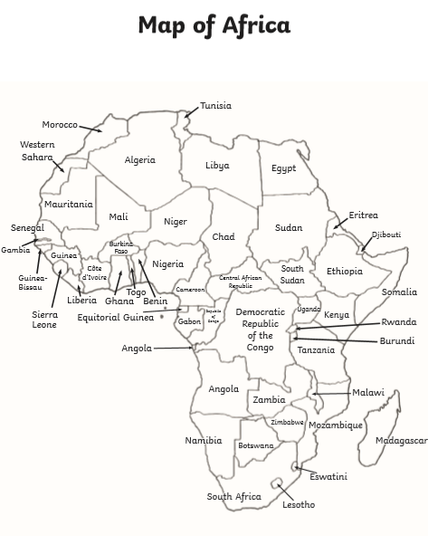

What does the flag look like?

What is the weather like?

