Year One
W/C 22.06.20

Weekly Phonics:
- Your child is currently accessing Phase 5.
- Use www.phonicsplay.co.uk to access activities from Phase 2 to Phase 5 (Username: march20 Password: home).
- This week practise alternative spellings for the ‘ow’ sound.
- Watch YouTube video https://www.youtube.com/watch?v=ySRd-Amrd28
- www.phonicsplay.co.uk Phase 5C – Alternative spellings for ‘ow’.
- Use www.spellingshed.com to practise spellings.
- I’ll be checking your new spellings on Friday and there are 50 extra honeypots on offer for every day you have practised!

Writing: The Tadpole’s Promise
- Paint, chalk or draw and colour this setting from the tadpole’s promise.

- Look at the different parts of the setting the trees, the tadpole’s playing. Using adjectives (to describe the nouns) and try and use adverbs (describing the verbs) to describe the setting e.g. The small, black tadpole was playing happily with his friend.
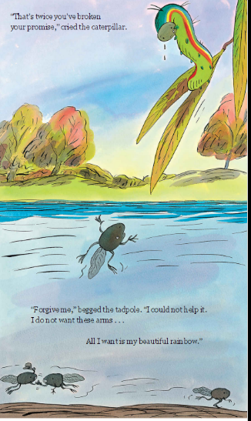

Reading:

- Use My Rising Stars website, log in to read your allocated books and attempt the activities/quizzes at the end. (These will be changed weekly)

Number Skills:
- Use the login provided to access www.mathsnoproblem.com
This week Year 1 will start chapter 16 (Textbook 1B) Time

Lesson 1 - Telling Time to the Hour
Lesson 2 - Telling Time to the Half Hour
Lesson 3 - Using Next, Before and After
Lesson 4 - Estimating Duration of Time

Time is quite a tricky concept so try and plan it into your regular routine- asking your child what the time is.

- Practise time game- https://mathsframe.co.uk/en/resources/resource/116/telling-the-time
- Practise number pairs to 10 – play http://www.ictgames.com/saveTheWhale/
- www.ttrockstars.com – use password provided to access Numbots
- www.10ticks.com - use password provided to access

P.E.
- Let’s Get Moving with Les Mills workouts ‘Born to Move’ https://www.lesmills.com/uk/workouts/kids-classes/born-to-move-8-12-years/
There are a variety of activities including dance and combat sessions.
- Go noodle on YouTube has a variety of get moving videos
https://www.youtube.com/user/GoNoodleGames

Geography
Recap where the equator, north pole and south pole are on a map.
Discuss whether they think the countries closer to the equator are hot or cold.
Or
The countries closer to the south pole and north pole are hot or cold.
Watch youtube video https://www.youtube.com/watch?v=5tC8OOxOFEk&t=9s

Task 1:
Ask your child to try and locate different countries on a map- ask whether they think it will be a hot or a cold country and why they thing that. For example, Peru is a hot country because it is near the equator and the sun shines directly on it.
Task 2:
Create a fact file about Kenya (Please find sheet under additional resources)
Location: Where is Kenya
Locate Kenya on a wold map- explain where it is near the equator or the poles, discuss what continent it is in and what oceans surround the continent.
What does the flag look like?
Research what the Kenya flag looks like and draw it.
Climate: What is the weather like?
Then start to research about Kenya and its climate- google what the weather is like.
Draw a picture of the weather e.g. sun, rain then explain what the weather is like. Explain why the weather is like that e.g. closer to the equator so it gets more of the sun.

Science
- Discuss and revisit how seeds disperse
- This week we are looking at Do we eat seeds? Are there any bulbs we eat?
- Talk to your child think about is there any seeds that we can eat.
- Have a few examples for your child to try e.g. pumpkin seeds, peas, beans
- Task – children complete the sorting activity for parts of plants we eat (Additional resources)

R.E
- Go back to when you were thinking about big questions about the world.
- Discuss with your child what are your hopes for the world e.g. so much plastic everywhere- our hope is that our world will start to reduce its plastic waste.
ICT
- As your child logs into our online learning resources, continue to talk to them about the importance of keeping all passwords safe.
- Dance mat typing: get those finger moving (this helps with keyboard recognition and familiarisation) https://www.bbc.co.uk/bitesize/topics/zf2f9j6/articles/z3c6tfr

