The Wolds Dragon
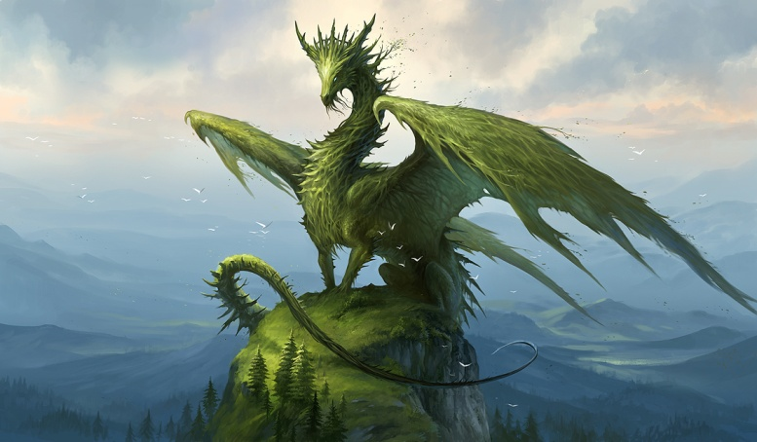
Dragons have roamed the world for thousands of years but are becoming ever more elusive. They usually roam the skies at night, high above the clouds out of sight. As they’re such a secretive animal, dragon sightings are rare.
Perhaps the most secretive dragon of all is the Wolds Dragon. As the name suggests, the Wolds Dragon is found in the hilly habitat of the Yorkshire Wolds. Sightings of this rare beast number only four, although their eggs are more commonly found, especially in the small village of Bishop Wilton.
A fully grown Wolds Dragon

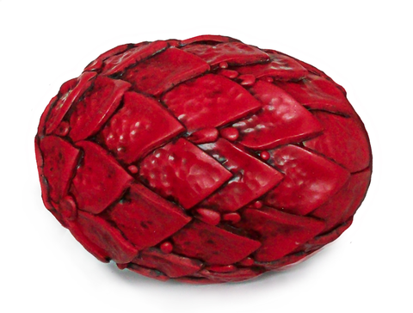
Wolds Dragon Eggs
Wolds Dragon eggs are red and covered in scales. They are heavy. Wolds dragon eggs are easy to find but people think they’re footballs.
Did You Know?
Wolds Dragons are reptiles. Just like snakes, they’re cold blooded and their young are born from eggs.
A Wolds Dragon Egg

Eating
Wolds Dragons eat sheep. There are lots of farmers in Yorkshire so there is a lot of food for the dragons.

