Year Two
W/C 27.04.20
Weekly Phonics:
- Your child is currently accessing Phase 6.
- Use www.phonicsplay.co.uk to access activities from Phase 4 to Phase 6 (Username: march20 Password: home).
- This week practise writing numbers up to ten (these will be your spellings this week)
- This week focusing on alternative spelling of n as gn and kn https://www.youtube.com/watch?v=h9hYdHhxVbQ
- Give your child some words that contain kn and gn children write these e.g. knife, knight, gnome, knew, knock
- Use www.spellingshed.com to practise spellings. Spelling lists will be changed weekly.

Writing:
- Draw either Jack or the Giant from the Jack and the Beanstalk
- Write some adjectives around your picture to describe your character. Think about what your character looks like what they are wearing but also think about how they are feeling. Are they feeling excited or sad and why do you think that?
- Using your fantastic adjectives that you have written. Write a paragraph describing your character.
Reading:
- Use My Rising Stars website, log in to read your allocated books and attempt the activities/quizzes at the end. (These will be changed weekly)
- A selection of books has been provided. Read your child’s own books to them. Can they ask you a question about each page read?

Number Skills:
- Use the login provided to access www.mathsnoproblem.com
This week Year 2 can continue Chapter 14 (Textbook and workbook 2B) –Time and explore the 4 lessons:
Lesson 5 - Finding Durations of Time
Lesson 6 - Finding Durations of Time
Lesson 7 - Finding Ending Times
Lesson 8 - Finding Ending Times

- Remember to use lots of real items to practise the tasks and allow children to gain a good understanding.
- www.ttrockstars.com – use password provided
- www.10ticks.com - use password provided to access

Other:
P.E.
- You could use Joe Wicks workout sessions on his YouTube channel.

Geography
This week we are looking at the different types of weather. What are the different types of weather?
- Create your own or use twinkle’s (see example at the end of document) weather diary. This week each day I want you to record what the weather is like. What can you see, what can you hear, how has the weather changed, then draw the weather. Remember to write the time you wrote it and what the temperature was.
Science
- This term we will be looking at plants.
- This week we are thinking about what things do plants need to grow
- If you can plant a seed, think about what your seed might need to grow and why
- Draw a picture of your favourite part of planting a seed and explain why
- Complete plants need worksheet on twinkl https://www.twinkl.co.uk/resource/au-sc-2046-plants-need-activity-sheet

R.E
- This week in RE we are learning about the Christian creation story
- Go through the powerpoint on twinkl https://www.twinkl.co.uk/resource/t-t-5364-adam-and-eve-story-powerpoint. Answer questions: How many days did God take to create the world? Can you remember some of things God created?
- Create a creation wheel (see example at the bottom of document)
- Split a circle into 8 parts- in each part draw a different thing that God created on each day
D&T/Art
- Go outside and find a snail, or look online. Look at a snail’s spiral.
- On a piece of paper draw your own spiral and use different colours either colouring pencils, paint to colour in your picture. For inspiration look at some of the pictures below.
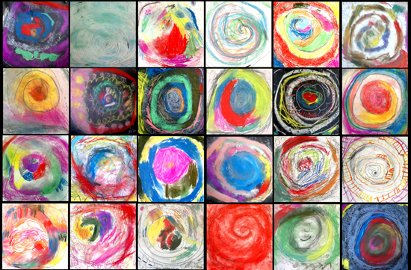

Geography: Weather diary https://www.twinkl.co.uk/resource/t-g-046-my-weather-diary
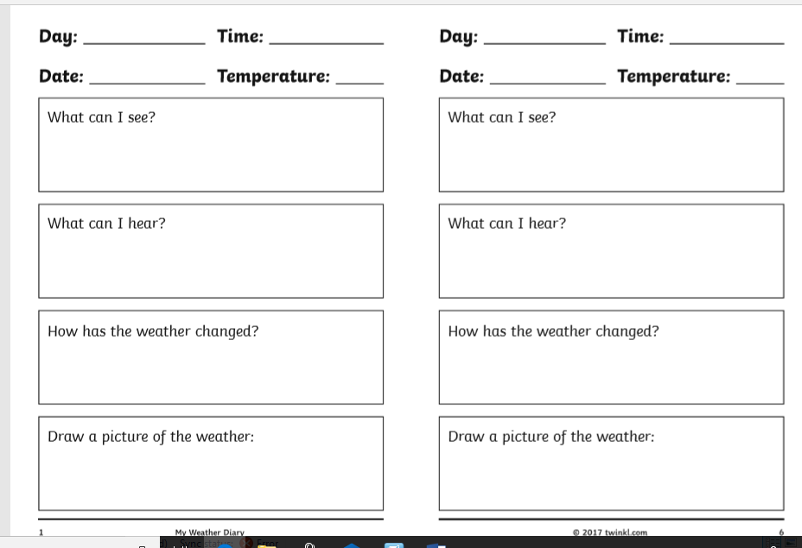

RE: Creation wheel
