Year One
W/C 20.04.20
Weekly Phonics:
- Your child is currently accessing Phase 5.
- Use www.phonicsplay.co.uk to access activities from Phase 2 to Phase 5 (Username: march20 Password: home).
- Practise flashing the phase 5 grapheme fan (In your child’s book bag)
- This week practise adding the suffix ‘s’ and ‘es’
- Watch the YouTube video of what the rule is and when to add ‘s’ or ‘es’ to make the word plural https://www.youtube.com/watch?v=RhPubTi8GHQ
- Go round the house finding objects, get your child to write labels for them for them adding either ‘s’ or ‘es’.
- Use www.spellingshed.com to practise spellings. Spelling lists will be changed weekly.

Writing:
- Read a version of Jack and the Beanstalk or watch one on YouTube (https://www.youtube.com/watch?v=zurz-pL-uzw ). Make some props, dress up and act out the story with your family.
- Draw a story map (example attached) and re-tell the story to your favourite teddy and then to an adult using some of the language in the story.
- Write a paragraph to say which part of the story you liked best and remember to explain why.
Reading:
- Use My Rising Stars website, log in to read your allocated books and attempt the activities/quizzes at the end. (These will be changed weekly)
- A selection of books has been provided. Read your child’s own books to them. Can they ask you a question about each page read?

Number Skills:
- Use the login provided to access www.mathsnoproblem.com
This week Year 1 could begin the lessons for Chapter 10 (Textbook and workbook 1B) – Numbers to 40 and explore the first 4 lessons:
Lesson 1 - Counting to 40
Lesson 2 - Writing Numbers to 40
Lesson 3 - Counting in Tens and Ones
Lesson 4 - Comparing Numbers
. Remember to use lots of real items to practise the tasks and allow children to gain a good understanding.
- www.ttrockstars.com – use password provided to access Numbots
- www.10ticks.com - use password provided to access

Other:
P.E.
- You could use Joe Wicks workout sessions on his YouTube channel.

Geography
- Look at a map of the UK. Can you point to where we live?
- Name the four countries in the UK and learn the names of their capital cities.
- Challenge – Can you find the capital cities on a map?

Science
- This term we will be looking at plants.
- Go on a plant hunt in your garden. Can you name and draw five different plants?
- Draw a plant with a flower, petals, leaves, stem and roots. Cut it up to make a jigsaw. Can you put it back together and name the different parts?

R.E
- Ask your child to think about some ‘big questions’ they might want to ask (eg Why doesn’t everyone have enough food? Why do bad things happen? Where did the world come from?) Make a list of the questions and talk about the fact there isn’t always an answer.

D&T/Art
- Think about the work we did on land art in the style of Andy Goldsworthy. Make your own representation of a plant in your garden using all the different materials you can find. Photograph it if possible.

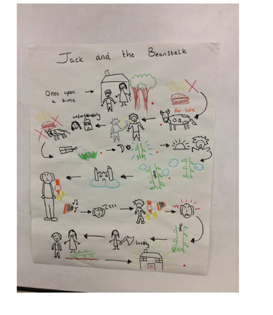
Example of story map: Jack and the Beanstalk

