Middleton on the Wolds – Reception
Hi everyone,
I hope you are all ok and have had a lovely Easter. I have added below a suggested daily phonics lessons for the next week or so –As you can see, phonics is very repetitive - each day we follow the same lesson structure; recap, teach, practice, apply and you will see each day you are following a simplified version of this. If you want to drop me an email and let me know what you think or how you are getting on with home learning? ramsdenp@middleton.eriding.net.
Thanks
Miss Ramsden
Suggested daily phonics activities - resources – whiteboards/pens/ i-pad or computer to play phonics play, phoneme frames either hand drawn or printed, 4x new tricky word flashcards (handwritten is fine): Have, like, it’s, you. (You will also need the 4 taught previously said/so/went/from)

Day | Morning 20-25mins
Monday | Recap all sounds in red sound book – go through the book and ask the children to read them *mix it up a bit – pick random ones, start from the beginning of the book etc. Recap and child reads the tricky words said/so/went/from - ensure these words are recognised before introducing new ones (see below)  Adult writes or creates flashcard with new tricky words- Have/like  If possible, draw or prepare picture cards depicting these words, then create flash cards. Model, looking at the picture, thinking what the word could be and then find the corresponding word.  Frog, swim, plug, snap  Adult dictates word “sniff”, demonstrates how to write it and then child copies. For the next words, adult dictates and child writes the word – either on whiteboard, or in a phoneme frame if needed.  sniff, plum, gran, swim, clap.  Adults writes the sentence and helps children to read it  The clown did tricks with gran.  I swim in a pool.
Tuesday | Recap all sounds in red sound book – go through the book and ask the children to read them *mix it up a bit – pick random ones, start from the beginning of the book etc  Recap and child reads the tricky words said/so/went/from - ensure these words are recognised before introducing new ones (see below)  Children practice reading tricky words – have/like  Adult writes and children read words:  green, fresh, smell, snack.  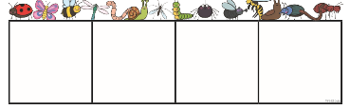  Segmentation for spelling - Play Filling in the Blanks – adult says the word, writes it but with some missing letters, children figure out what phonemes(letters) are missing and then they write the missing letters.  brown, clock, flag, prod, grab.  *if children are struggling then draw a phoneme frame for children to write each phoneme (letter) in –  Phoneme frames can be downloaded to print or you can just draw it  https://www.twinkl.co.uk/resource/t-l-564-minibeast-phoneme-frames  Children write sentences on whiteboards- adult dictates and children write  A crab crept into a crack in the rock.
Wednesday | Recap all sounds in red sound book – go through the book and ask the children to read them *mix it up a bit – pick random ones, start from the beginning of the book etc  Recap and child reads the tricky words said/so/went/from - ensure these words are recognised before introducing new ones (see below)  Children practice reading tricky words – have/like and introduce – if child is ready – it’s  *To keep children engaged and interested in doing this – you could hide the words around a room, stick them up in the garden - adult shouts a word and child has to run to it or run and find it – you could also do this activity with any of the words the children learn during the sessions with you.  Adult writes and children read the following words: cloop, swing, dreen, float, smarp, groan – or log on to phonics play – phase 4 and play buried treasure  Segmentation for spelling - Play Filling in the Blanks *same as previous day - spark, bring, crash, bleed, clown.  Children write sentences on whiteboards- adult dictates and children write  I was at the pond for a swim.
Thursday | Recap all sounds in red sound book – go through the book and ask the children to read them *mix it up a bit – pick random ones, start from the beginning of the book etc  Recap and child reads the tricky words said/so/went/from and the new ones from this week - have/like/it’s  Show children the word “you” – do they recognise it? - Explain to child, if we were to segment and sound the word out “y-o-u” it doesn’t say you, this is why it’s a tricky word because we just say the word you – we can’t sound it out.  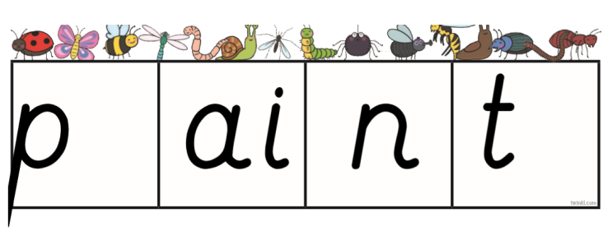  Adult writes and children read the following words - clot, creep, brown.  Segmentation for spelling - Play Filling in the Blanks – adult writes part of the word in the frame with letters missing – children have to say the word and figure out which letters are missing the make the word complete.  brush, growl, frown, bleep, train, smart - *use a phoneme frame if children are finding this tricky, red letters show digraphs (2 letters which make one sound)  Writing sentence – adult dictates to child -  You look sad.  Can you see the green frog?  The brown cow is sleeping.
Friday | Recap all sounds in red sound book – go through the book and ask the children to read them *mix it up a bit – pick random ones, start from the beginning of the book etc  Children read tricky words - Said/so/went/from and the new ones from this week - have/like/it’s/you  Adult writes flash cards/on paper/ on boards and then children to read pseudo words and real words smeet, thrill, fluck, flash, crash, crish.  If possible, print out or draw pictures of the following animals.  Show children the animal pictures: snail, skunk, crab, slug, frog, cat, dog, pig.  Ask them to write them in two lists, those they like and those they dislike.  Adult writes and then asks child to read the following sentences:  The frog jumps in the pond and swims off.  A slug is sat on a rock.  The black dog sits on a green mat.

