Name: __________________________________________

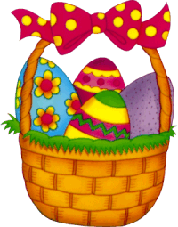
FUN!
Easter Homework Pack

Have a great Easter!

1. Times table crosswords
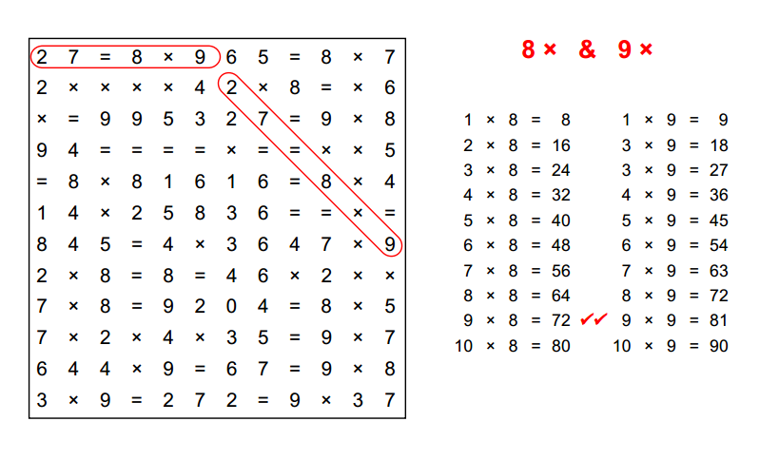
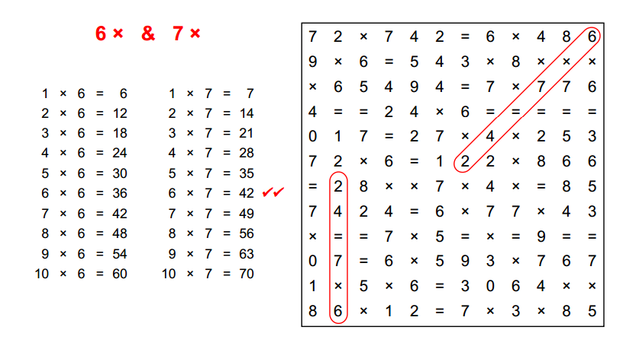
Use the times table crossword puzzle to practice your tables. I’ve started you off with an example. All you have to do is find the calculation and answer that’s correct – it’s somewhere in the crossword!

2. An Easter Recount
Think about the most exciting thing you’ve done over Easter and write a story about this. If you’ve done absolutely nothing but sleep or can’t think of something then make it up.
When you write your story don’t forget to tick off all of these things:
Past tense Metaphors (little lies)
Capital letters and full stops Question marks
Wow words Similes (“like a”, “as a”)
Noun, who/which/where sentences

3. Word-Type Word Search
The word search below has different types of words hidden within it. Can you find them all and circle them in the right colour? Make sure you use the right colours:
- Nouns – red
- Adjectives – blue
- Verbs – green
- Pronouns – yellow

